My Wisconsin:
Some of the people and events that have made Wisconsin natural resources special
By Tim Eisele

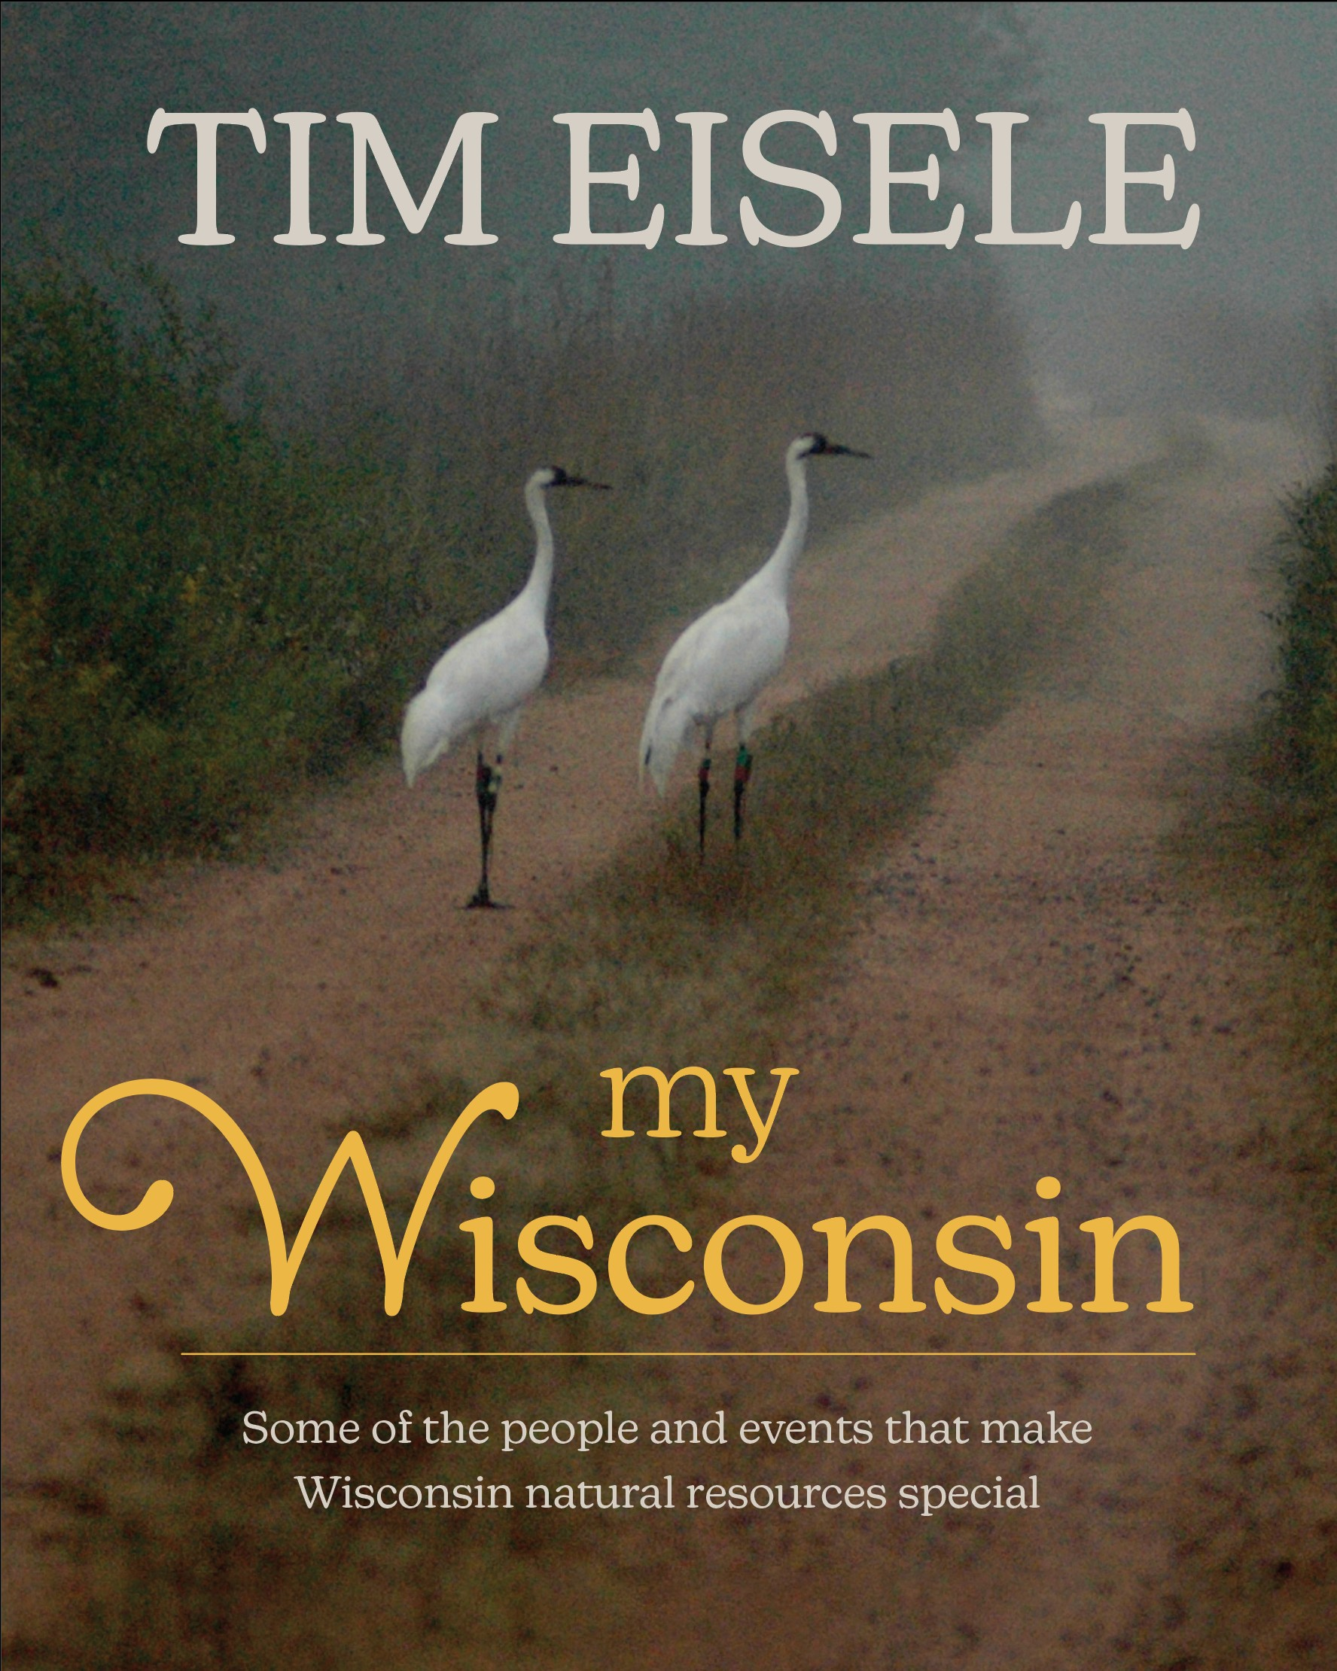
Larry Meiller: “I thought I knew a great deal about our state’s natural resources, but I confess I learned much more from Eisele’s enjoyable book.”
Dean Bortz: “Conservation historian. Very well done.”
Dave Gjestson: “A fascinating variety of stories about wildlife, the environment, and conservationists”
Paul Smith: “I've always admired veteran journalist Tim Eisele for his diligence in accurately recording and reporting on Wisconsin outdoors issues.”

Read the experiences of duck hunters who were stranded overnight during the November 11, 1940 Armistice Day storm; learn what Aldo Leopold was like from interviews with his daughters and Mrs. Leopold’s special recipe for cooking wild ducks; read the story of the return of wild turkey to Wisconsin’s landscape; learn about the investigation into the 1971 killing of a DNR wildlife technician; understand the importance of the non-partisan Natural Resources Board and an independent Department of Natural Resources; understand the need to switch to non-toxic ammunition to save lives of Bald Eagles; and hear from conservationists Herb Behnke, Dan Trainer, Cliff Germain, George Meyer, Governor Warren Knowles, and many more.

To Order: Send a check for $35 plus $6 shipping to: Gobbler Ridge Press, 129 South Segoe Road, Madison, Wisconsin 53705-4936.

Your name:___________________________________________________
Your address:_________________________________________________
City, State, Zip:________________________________________________
If desired a signed copy, please spell the name and his/her main interest in natural resources.

Thank you on behalf of Wisconsin’s natural resources!

